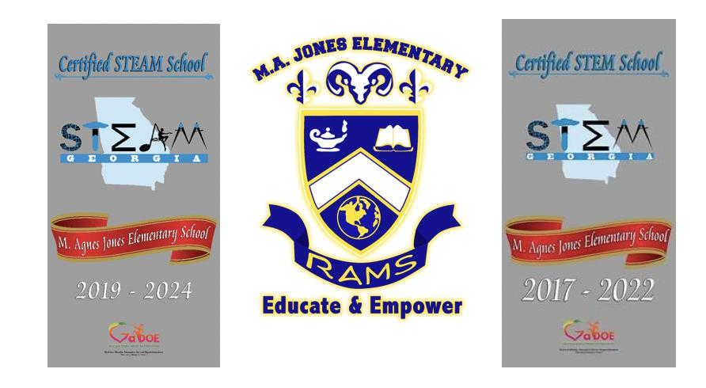

**School Family Engagement Plan**

***M. Agnes Jones Elementary***

***2024-2025***

***Revised 5.02.24***

**FAMILY ENGAGEMENT PLAN**



**M. Agnes Jones’ School Goals:**

* **3rd -5th grades** - Increase the percentage of students in the Developing, Proficient and Distinguishedcategories by 3% while decreasing the percentage of Beginning Learners by 3% in each of the core content areas based on GMAS (state standardized assessment).
* **K- 2nd grade –**Increase the percentage of students in At/Above Grade Level, On Watch andIntervention by 3% while decreasing the percentage of students in Urgent Intervention by 3% according to Success For All and NWEA Map .
* Increase the percentage of students with at least 90% attendance by 3% (from 77% to 80%).

A. We will involve parents in an organized, ongoing, and timely way in the planning, review, and improvement of school wide programs and the school family engagement policy by involving parents in the planning, review, and improvement of the comprehensive school wide program plan by surveying and using key points from the survey to implement changes. Parents provided valuable input in meetings formed to discuss the plan. Parents assisted in writing the plan. M. Agnes Jones Elementary School, jointly with our parents, has developed a family engagement policy that addresses our family engagement needs. This plan has been made available to the school staff, parents and the public. Copies of the plan have been placed in the Parent Center, sent home to parents by their children and disseminated at parent meetings. The plan has also been uploaded to the school website.

1. We will update the school family engagement policy periodically to meet the changing needs of parents and the school and distribute it to the parents of participating children and make the family engagement plan available to the local community, by posting an updated and revised plan in the parent center and uploading a copy to the school’s website.
   1. We will conduct an annual meeting, at a convenient time, to inform parents about the school’s Title I program, the nature of the Title I program, the parents’ requirements and the school family engagement policy, the school wide plan, and the school-parent compact and encourage and invite all parents of participating children to attend by encouraging parents to participate in school activities, visit the school and establish positive working relations with their child’s teacher. Grade levels have Academic Parent-Teacher Team (APTT) parent meetings that address issues such as the GMAS standards – based curriculum as well as identify one or two target skills to improve based on student grade level data. To promote family engagement, the school sends home periodic

newsletters, keeps monthly communication phone logs, invites parents to visit classes, surveys parents, encourages parents to eat lunch or breakfast and encourages attendance at programs. We have provided light fare at the majority of our APTT meetings in order to increase parents’ attendance at the monthly meetings. The instructional coaches will also sponsor monthly parent workshops centered on academic issues that encourage parents to support their children at home.

We will offer a flexible number of meetings, such as meetings in the morning or evening, and may provide, with funds provided under Title I, transportation, childcare, or home visits, as such services relate to family engagement by offering activities at different times of the day and on weekends to maximize participation. Parents are engaged through APTT, GoTeam and PTA meetings. Parents are welcomed to visit the school and develop a working relationship with their child’s teacher. Additionally, they can utilize the Parent Center which houses parent education materials, a conference table and computer. The Parent Center is in the Learning Commons. The Family Learning Workshop provides:

* + Interactive training that leverages technology tools to build parents’ capacity, improve student literacy, and support student success and STEAM learning.
  + Parents/Family members learn strategies on how to become stronger learning partners for their children, how to responsibly access and utilize digital resources for learning, the value of home-school connection, and how to support 21st century learning at home both on and off-line.
  + All training and outreach materials are presented and available in English and Spanish.

1. We will provide parents of participating children with timely information about the Title I program, a description and explanation of the curriculum in use at the school, the forms of academic assessments used to measure student progress, and the proficiency levels students are expected to meet, and provide opportunities for regular meetings, if requested by parents, to formulate suggestions and to participate, as appropriate, in decisions relating to the education of their child, and respond to any such suggestions as soon as practicably possible, by implementing strategies used to increase the level of communication between school and home include: (1) Quarterly newsletter – “The Rams Reporter,” (2) APTT meetings, (3) Student of the Month , (4) parents as room parents, (5) Annual parent feedback surveys, (6) GoTeam (7) quarterly progress reports (8) Monthly Save the Date Notices (9) Marquee Displays (10) Monthly assembles that include parent information and celebration (11). MAJ website, Facebook, Twitter (social media).
2. We will jointly develop with parents of participating children a school-parent compact that outlines how parents, the entire school staff, and students will share the responsibility for improved student academic achievement and the means by which the school and parents will build and develop a partnership to help children achieve the state’s high standards by having the parents and the school meet to decide the expectations for the school, parent and student. The school-parent compact will go home with every student. Feedback from parents will be welcomed and used to inform decisions.
3. We will provide assistance to parents of participating children, as appropriate, in understanding the state’s academic content standards, the state’s student academic achievement standards, the state and local academic assessments including alternate assessments, the requirements of Title I, Part A, how to monitor their child’s progress, and how to work with educators, by meeting with parents during parent nights and individually to share and discuss the grade level academic standards. The parents will be provided information regarding the GSE though website links in parent communications and copies of the GSE/Units of Study in the parent center. Additionally, parents will receive training on assessments during parent meetings. Parents will receive information on NWEA Map and GMAS or other Georgia Department of Education Standardized Assessments.

The school will provide progress reports, report cards, NWEA Map reports (reading/math) and information regarding access to the Parent Portal to monitor their child’s progress. Parent conferences will be conducted by teachers and two-way communication is an expectation between school and home.

1. We will provide materials and training to help parents to work with their child to improve their child’s achievement, such as literacy training, STEM training and using technology, as appropriate, to foster family engagement. Parents will be engaged in ongoing training and support from Power My Learning. Training will center on computer and online resources to support all content areas. Instructional Coaches will encourage parents to attend parent workshops that relate to supporting their children through the core content areas. The coaches will provide project boards, paper, crayons and markers to parents that help in supporting the children completing assignments outside of the regular school day. The parents are able to utilize the computer in the parent center to support their child(ren)’s academic needs.
2. We will provide training (APTT) to educate the teachers, pupil services personnel, principal, and other staff in how to reach out to, communicate with, and work with parents as equal partners, in the value and utility of contributions of parents, and in how to implement and coordinate parent programs, and build ties between parents and the school, by conveying to parents that they are a vital part of the decision making at M. Agnes Jones. Parents are invited and encouraged to identify parent programs that they feel are useful and meet their needs in supporting their children. Additionally, the school will provide parent trainings related to the core content areas. Parents and school are meeting during GO Team meetings to ensure decisions are being made together and

information disseminated to all parties. Parents will be engaged in ongoing training and support. Training will center on computer and online resources to support all content areas.

1. We will, to the extent feasible and appropriate, coordinate and integrate family engagement programs and activities with Head Start, Even Start, Home Instruction Programs for Preschool Youngsters, the Parents as Teachers Program, and public preschool and other programs, and conduct other activities, such as parent resource centers, that encourage and support parents in more fully participating in the education of their children, by contacting community preschools and Head Start programs to solicit support in involving their parents in M. Agnes Jones activities and resources. Newsletters will be shared with these entities and invitations to events such as Fall Festival, curriculum nights and parent meetings.
2. We will take the following actions to ensure that information related to the school and parent programs, meetings, and other activities, is sent to the parents of participating children in an understandable and uniform format, including alternative formats upon request, and, to the extent practicable, in a language the parents can understand, by ensuring that all communication is understandable to all parents. We will send home written messages, Class Dojo, e-mails, school newsletter and calling posts event notifications in other languages when the need arises.
3. We will provide full opportunities, to the extent practicable, for the participation of parents with limited English proficiency, parents with disabilities, and parents of migratory children, including providing information and school reports required under section 1111 of the ESEA in an understandable and uniform format and including alternative formats upon request, and, to the extent practicable, in a language parents understand, by ensuring that all communication is understandable to all parents. We will send home messages and event notifications in other languages when the need arises.